1.DATASET

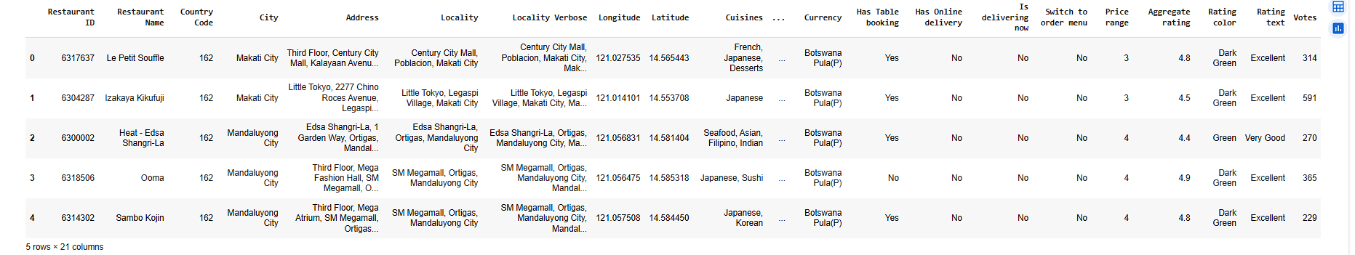

Step 1: Basic Checks & Renaming
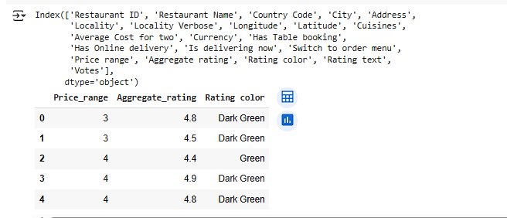

Step 2: Most Common Price Range

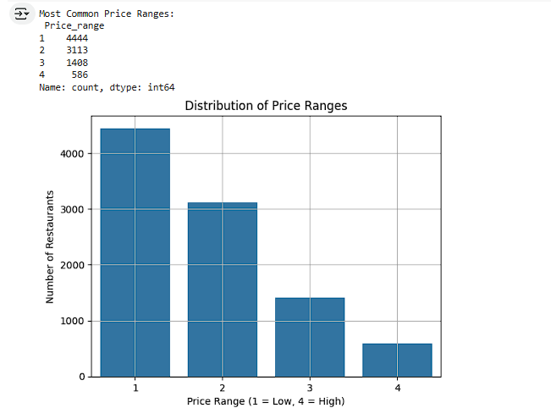
Step 3: Average Rating for Each Price Range

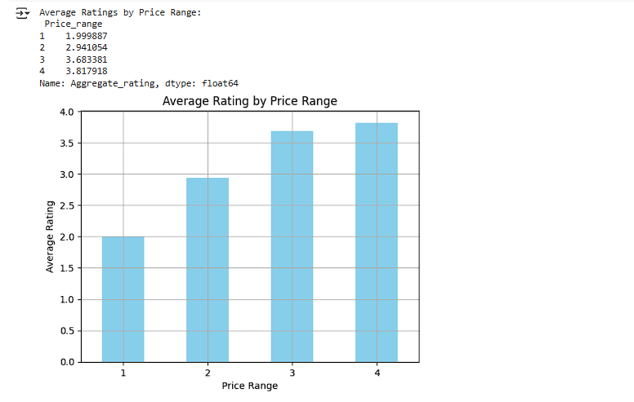

Step 4: Highest-Rated Price Range Color

